from kivy.app import App

from kivy.uix.boxlayout import BoxLayout

from kivy.uix.button import Button

from kivy.uix.textinput import TextInput

from kivy.uix.label import Label

from kivy.uix.image import Image

from kivy.uix.popup import Popup

from kivy.uix.gridlayout import GridLayout

from skimage import io, img_as_float

import numpy as np

class ImageComparisonApp(App):

    def build(self):

        layout = BoxLayout(orientation='vertical')

        self.image1_path_input = TextInput(hint_text="Input path image 1")

        self.image2_path_input = TextInput(hint_text="Input path image 2")

        compare_btn = Button(text='Cetak')

        compare_btn.bind(on_press=self.compare_images)

        self.result_label = Label(text="Hasil: ")

        # Widget BoxLayout untuk menampilkan gambar dalam satu baris

        image_row = BoxLayout(orientation='horizontal')

        # Widget Image untuk gambar 1

        self.image1 = Image()  # Atur ukuran gambar di sini

        image_row.add_widget(self.image1)

        # Widget Image untuk gambar 2

        self.image2 = Image()  # Atur ukuran gambar di sini

        image_row.add_widget(self.image2)

        layout.add_widget(self.image1_path_input)

        layout.add_widget(self.image2_path_input)

        layout.add_widget(compare_btn)

        layout.add_widget(self.result_label)

        layout.add_widget(image_row)  # Tambahkan widget BoxLayout dengan kedua gambar

        return layout

    def compare_images(self, instance):

        image1_path = self.image1_path_input.text

        image2_path = self.image2_path_input.text

        if not image1_path or not image2_path:

            return

        image1 = img_as_float(io.imread(image1_path))

        image2 = img_as_float(io.imread(image2_path))

        # Pemeriksaan jumlah piksel

        if image1.shape != image2.shape:

            # Buat pesan kesalahan yang mencakup jumlah piksel

            error_message = f'Error: Jumlah piksel gambar 1 = {image1.shape[1]}x{image1.shape[0]}, gambar 2 = {image2.shape[1]}x{image2.shape[0]} berbeda.'

            # Buat popup dengan pesan kesalahan

            error_popup = Popup(title='Error', content=GridLayout(rows=2), auto_dismiss=False, size_hint=(None, None), size=(600, 150))

            error_popup.content.add_widget(Label(text=error_message))

            # Tambahkan tombol "Kembali" ke dalam popup

            back_button = Button(text='Kembali')

            back_button.bind(on_press=error_popup.dismiss)

            error_popup.content.add_widget(back_button)

            # Tampilkan popup

            error_popup.open()

            return

        mse = np.mean((image1 - image2) ** 2)

        uaci = np.sum(np.abs(image1 - image2)) / np.sum(image1 + image2)

        psnr = -10 * np.log10(mse)

        npcr = np.sum(image1 != image2) / (image1.shape[0] * image1.shape[1])

        result_text = f"Hasil:\nMSE: {mse:.4f}\nUACI: {uaci:.4f}\nPSNR: {psnr:.4f} dB\nNPCR: {npcr:.4f}"

        self.result_label.text = result_text

        self.image1.source = image1_path  # Tampilkan gambar pertama

        self.image2.source = image2_path  # Tampilkan gambar kedua

if __name__ == '__main__':

    ImageComparisonApp().run()

211110419 – DAVID

REVISI ERROR JIKA UKURAN KEDUA GAMBAR TIDAK SAMA.

**PERCOBAAN -PERCOBAAN**

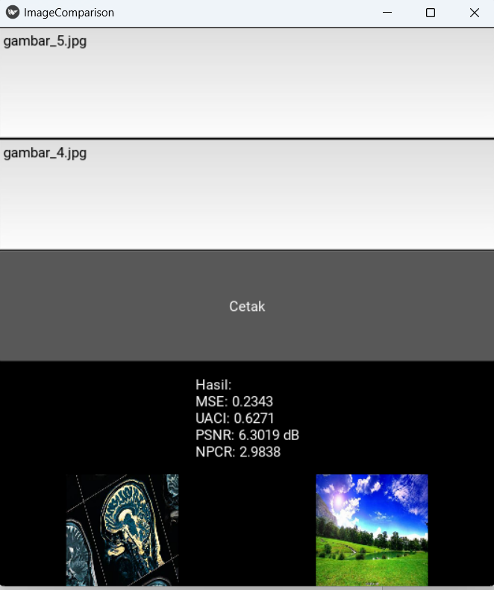

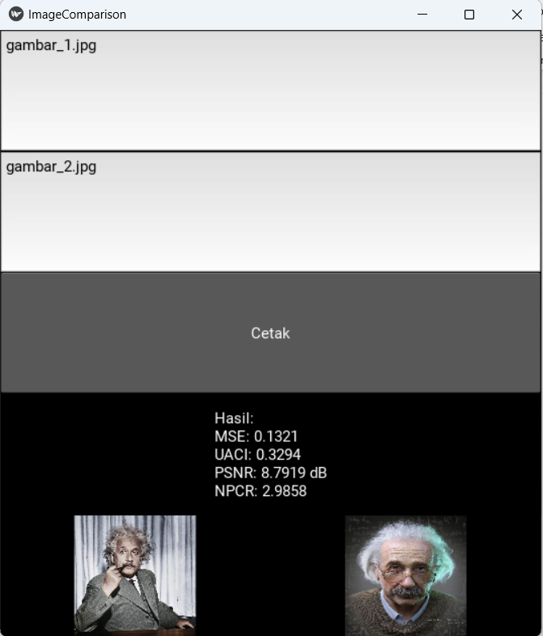

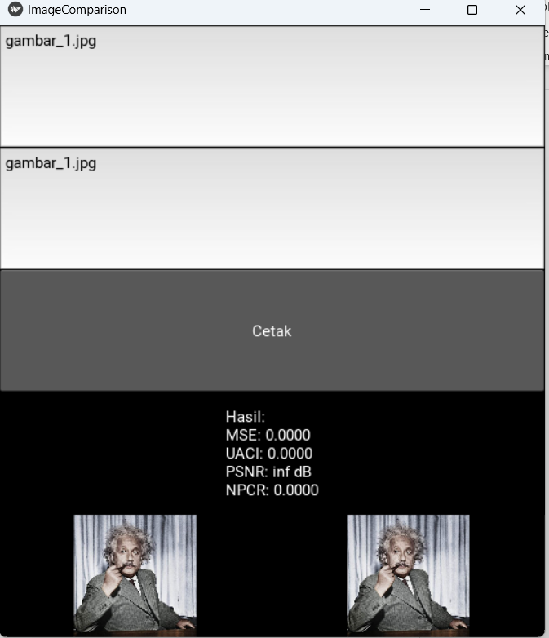

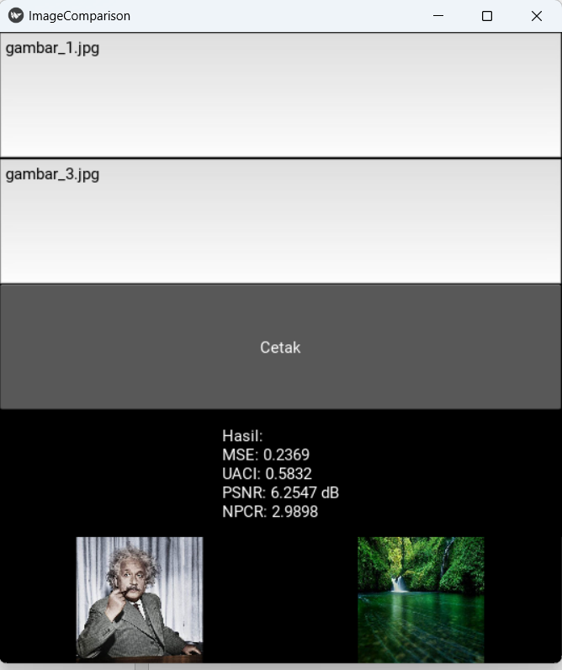

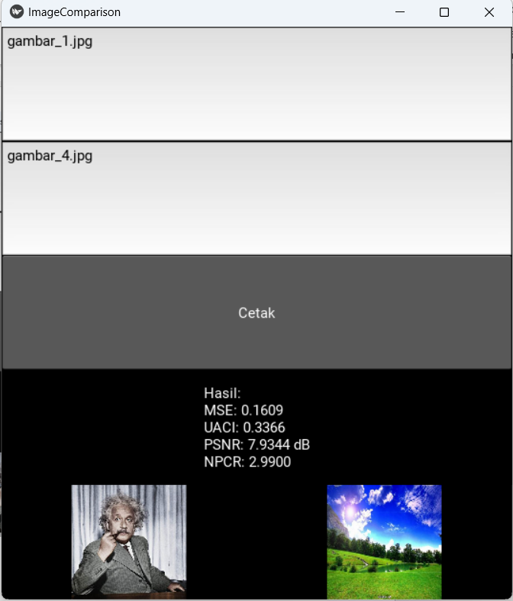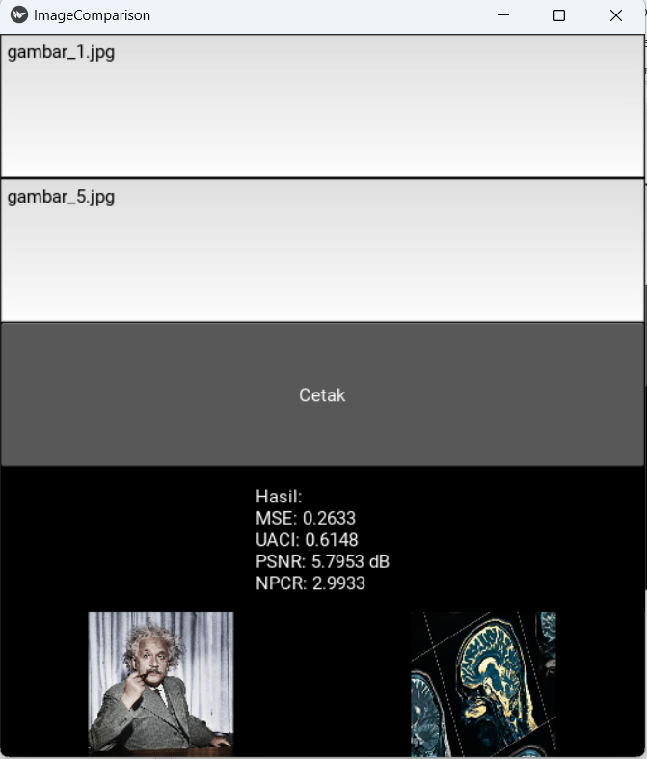

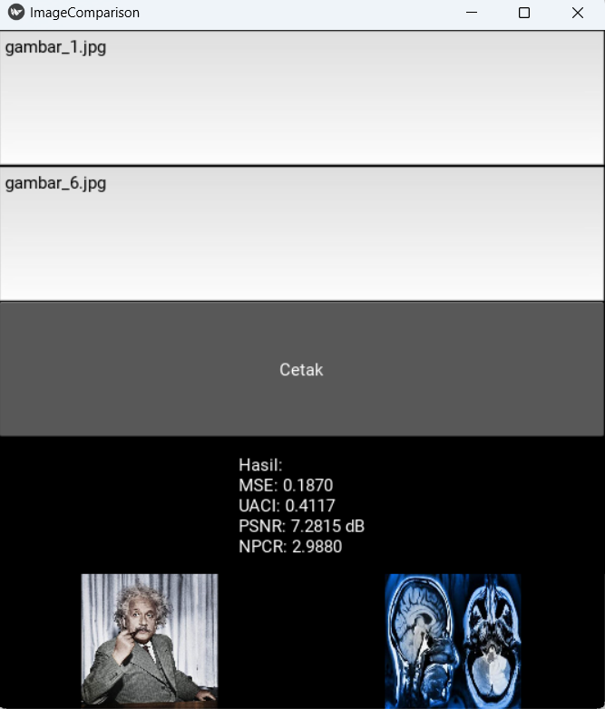

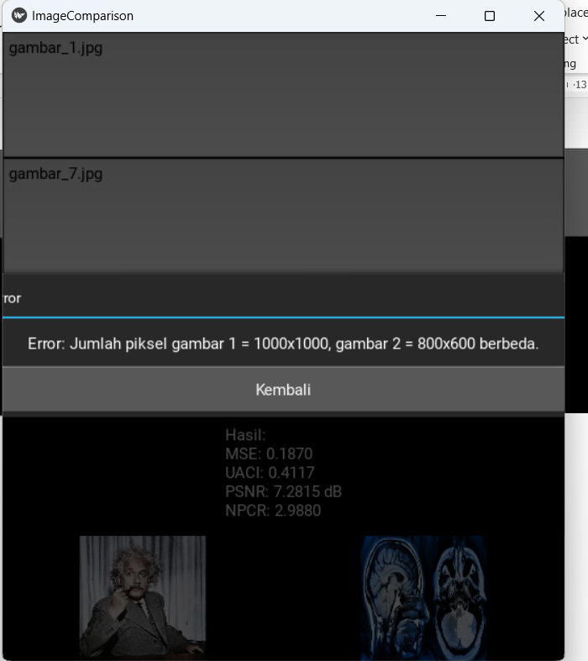

**NOTE : GAMBAR 7 BERBEDA UKURAN , MAKA AKAN MUNCUL PESAN ERROR SEPERTI DIATAS.**

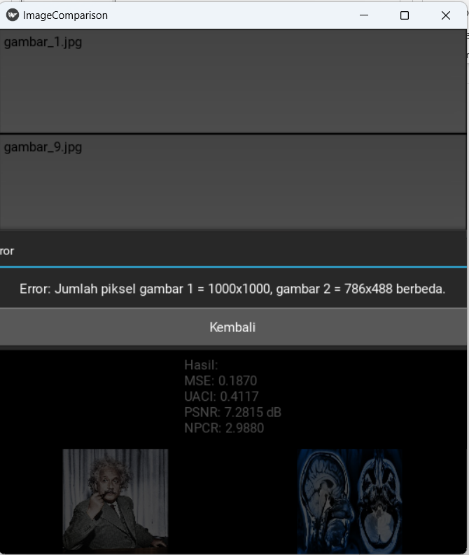

**NOTE : GAMBAR 9 BERBEDA UKURAN , MAKA AKAN MUCUL PESAN ERROR SEPERTI DIATAS**

